Flowchart #1 Single customer:
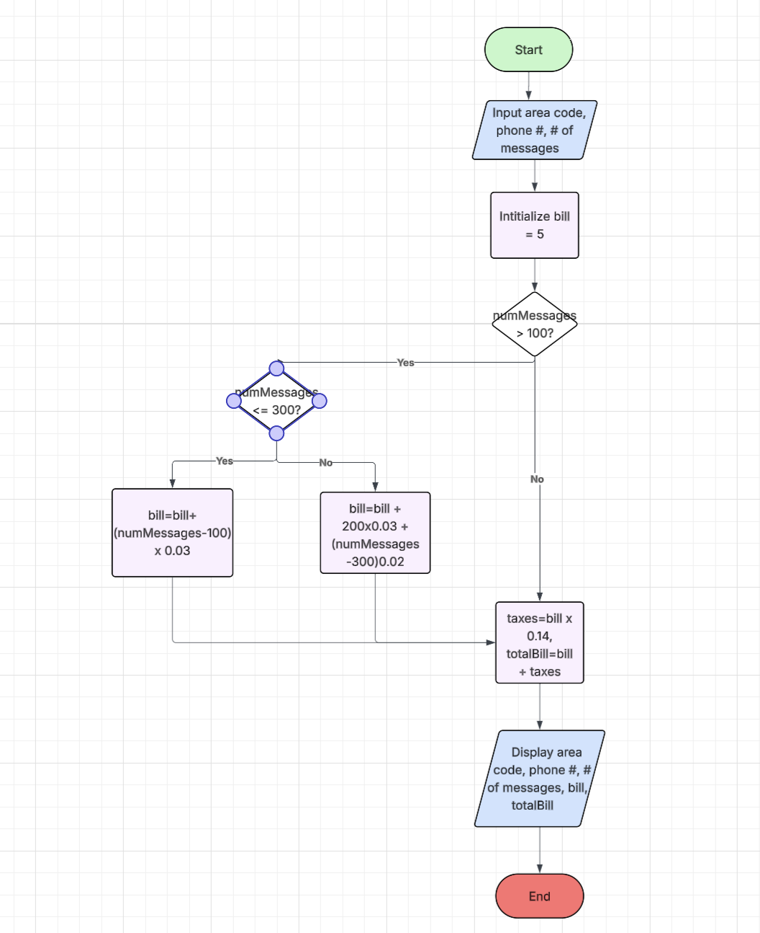
Flowchart #2 Multiple Customers:
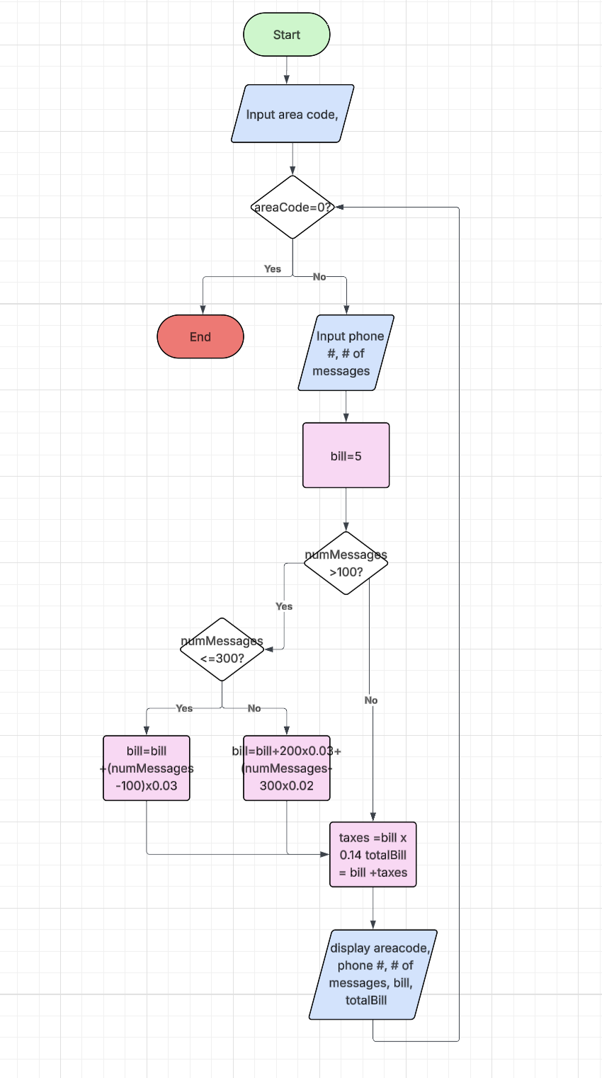

Flowchart #3 Multiple customers >100 Messages:
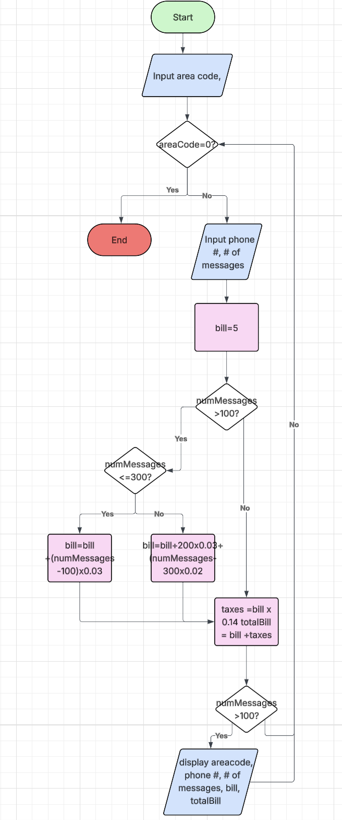
Flowchart #4 Customers with Total Bill > $10:
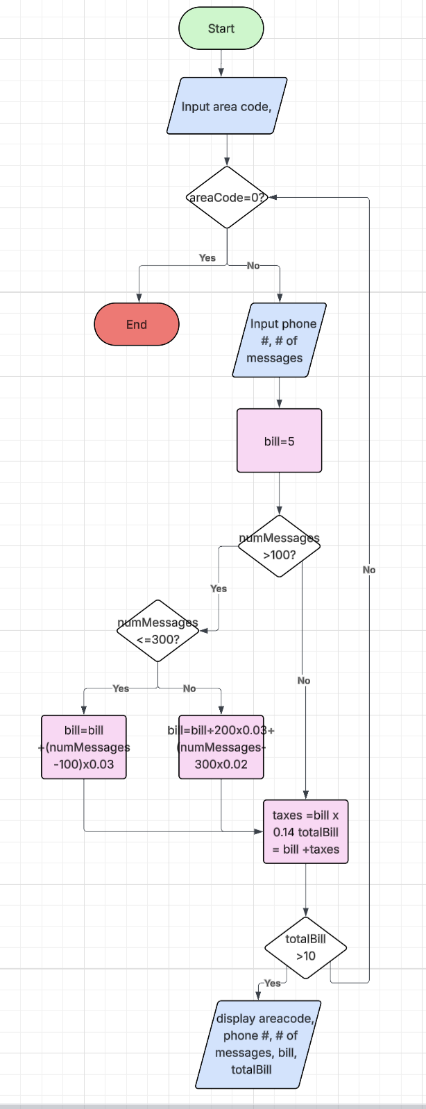
Flowchart #5 Customers from Specific Area Code:
